[Studio Portrait: Two Men each Holding Bamboo, Singapore]
John Thomson | 1860s | Record IMG-SEA0006

1. Original Image
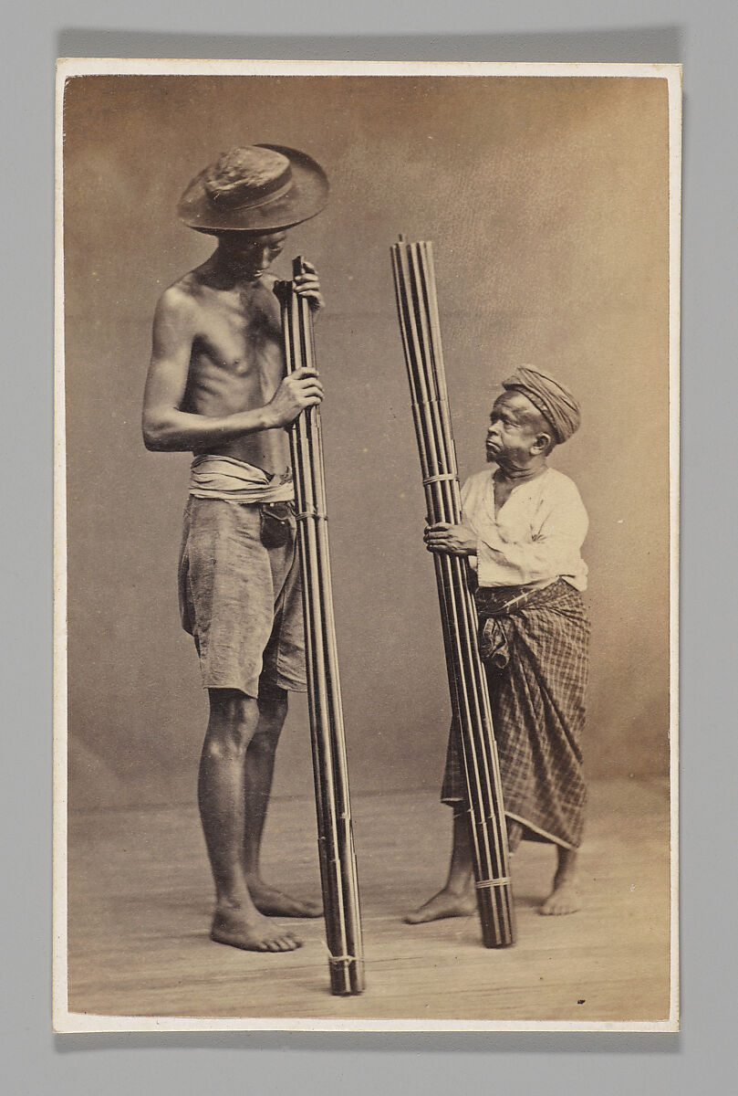
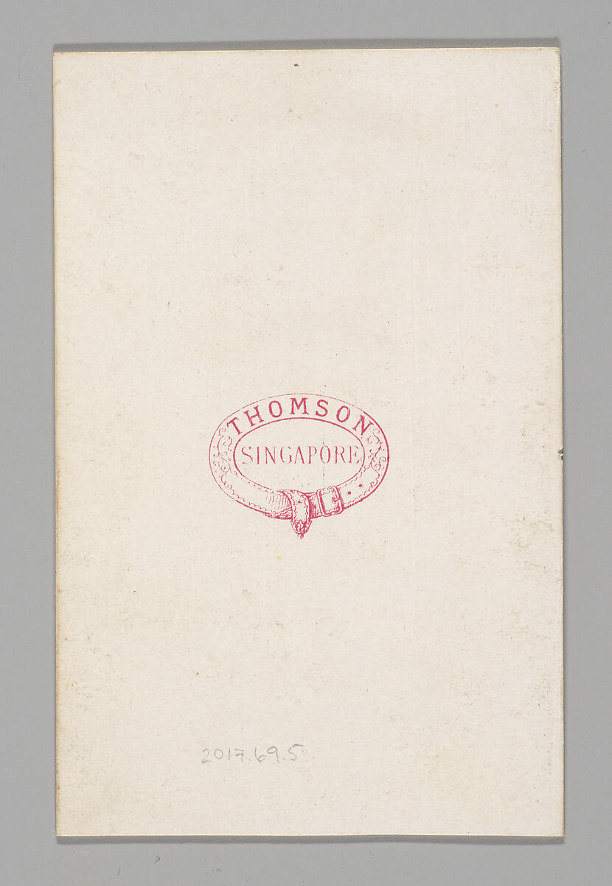
IMG-SEA0006. [Studio Portrait: Two Men each Holding Bamboo, Singapore], John Thomson (British, Edinburgh, Scotland 1837–1921 London), 1860s, Albumen silver print, Image: 9.3 x 6.0 cm Mount: 9.6 x 6.2 cm. The Metropolitan Museum of Art.

2. Record Summary
Record ID | IMG-SEA0006
Original title | [Studio Portrait: Two Men each Holding Bamboo, Singapore]
English title | [Studio Portrait: Two Men each Holding Bamboo, Singapore]
Alternative title | Bracketed institutional title
Creator | John Thomson
Creation date | 1860s
Country | Singapore
Cultural region | Southeast Asia
Historical period | Nineteenth-century colonial Singapore; carte-de-visite photography
Image type | Photography
Medium | Albumen silver print
Dimensions | Image: 9.3 × 6 cm; mount: 9.6 × 6.2 cm
Primary subject | Two adult men holding bundled bamboo tubes
Secondary subjects | Hats, wrapped garments, bare feet and studio backdrop
Source institution | The Metropolitan Museum of Art
Collection or object number (optional) | 2017.69.5

3. Image Description

3.1 Short Description
A vertical studio photograph shows two barefoot adult men standing against a plain backdrop. Each holds a tall bundle of narrow bamboo tubes upright. The taller figure at left wears a broad hat and wrapped lower garment; the shorter figure wears a head covering, light top and patterned lower cloth.

3.2 Detailed Visual Description
The taller man stands at left in near profile and turns his head downward toward the other figure. He is bare-chested and holds a bundle extending from the floor to above his shoulder. The second man looks upward and holds a similar, slightly shorter bundle.
Both figures are barefoot. Repeated horizontal ties secure the parallel bamboo tubes. Directional lighting defines the bodies, textiles and bamboo, while soft shadows fall on the studio floor. No furniture, landscape or written text is visible.

4. Formal Features
Field | Analysis
Composition | Paired vertical figures and bamboo bundles.
Viewpoint or camera angle | Waist-to-chest height.
Shot scale | Full-length double portrait.
Spatial depth | Shallow studio space.
Lighting | Directional light from the left.
Colour palette | Warm brown, beige and grey.
Contrast | Figures stand clearly against the lighter backdrop.
Visual focus | Exchange of gazes and parallel bamboo forms.
Texture | Skin, cloth, hats and bamboo.
Movement or stillness | Stationary poses with implied interaction.
Medium-specific features | Small mounted carte-de-visite format.

5. Historical Context and Purpose

5.1 Historical Context
The Met dates the photograph to the 1860s and identifies Singapore through its bracketed institutional title. The carte de visite was a small mounted photographic format that could be produced economically and circulated in albums. Such images included personal portraits, celebrities and anonymous figures presented as social or occupational “types.” The title does not identify either sitter personally or explain the exact function of the bamboo bundles. [IMG-SEA0006-S01] Image Purpose and Circulation

5.2 Image Purpose and Circulation
Probable purpose: Commercial studio production and circulation, possibly as an occupational or ethnographic type image.
Current institutional use: Interpretation of mass-circulated nineteenth-century photography.

